no. 1 - PATH

Starting from SOURCE you have to arrive at TAP, changing the sequence of the words listed below. In the path, every word must be linked to the word before or after by changing a letter or by idea association.

Solution: SOURCE, open, sea, navigation, map, TAP

FIND THE MAGIC WORD

The six terms listed below are all linked to a seventh word by idea association. Which?

RECONSTRUCT THE SENTENCE

You must reconstruct this saying of the English writer from the 1700s, Thomas Fuller, using the words listed below and knowing that the correct diagram is:

You must reconstruct this saying of Jack Welch, former CEO of General Electric

CROSSWORD

You must work out how the words listed below fit into the grid - they all relate to the correct management of water resources. All except one. In fact, there is one word not connected with ecology, which must be left out. Which?
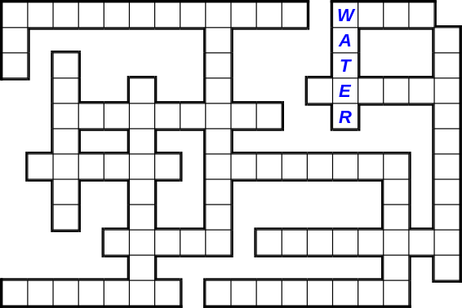

you must enter the words listed below into the diagram - they all relate to the sustainable management of energy and energy resources.
no. 18 - WORD SEARCH

The United States artist Andy Warhol, one of the most important figures in modern art, stated: “… is the most beautiful art that anybody could ever want to own.”

Find and circle the twenty-seven terms listed below that relate to WATER, ENERGY and the ENVIRONMENT. When you have finished, read the letters leftover to find out what he was referring to.
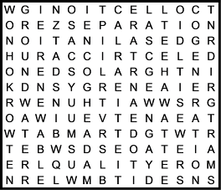

Solution: Having land and not ruining it
(see diagram)

Wystan Hugh Aden, a great English poet, said: “Thousands have lived without love, not one…”
How does the sentence end? Find and cross out the twenty-nine terms listed below that relate to WATER, ENERGY and the ENVIRONMENT. When you have finished, read the letters leftover to find out.

xxxxxxxx
“Water is the…” How did Leonardo da Vinci, an Italian Renaissance polymath (sculptor, painter, engineer, architect and much more!) define water?

Find and cross out the xxxx terms listed below that relate to WATER, ENERGY and the ENVIRONMENT. When you have finished, you will find out by reading the letters leftover.

“Our biggest challenge in this new century is to take an idea that seems abstract and turn it into a reality for all the world’s people”. This sentence was pronounced by Kofi Annan, Secretary General of the United Nations from 1997 to 2006. What was the Ghanaian diplomat referring to?

Find and cross out the xxx terms listed below that relate to WATER, ENERGY and the ENVIRONMENT and read the letters leftover to find out.

n. 19 - LABYRINTH

Where does the water we drink come from? From aquifers, springs, rivers and natural lakes. Or reservoirs, as in our case. Try to find the path that the water follows from the dam to your tap!

Did you know that with twenty-seven plastic bottles you can make a synthetic fleece sweatshirt? Find the path to help recycle the bottles and to safeguard the environment!

Solar energy, as you know, is a clean, renewable energy. Show the sun the right, ecological path to switch on the light bulb!

Solution:

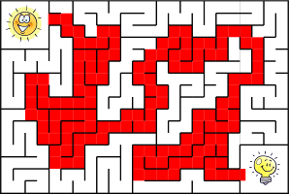

ARE YOU ECOLOGICAL? WATER

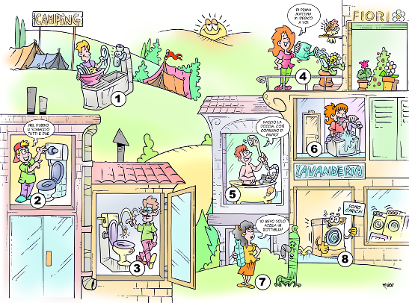

2  NEL DUBBIO LI SCHIACCIO TUTTI E DUE | 2  I’LL PRESS BOTH OF THEM, JUST IN CASE
4  DI PRIMA MATTINA MI DEDICO A VOI | 4  I LOVE WATERING THE PLANTS FIRST THING IN THE MORNING
5  FACCIO LA DOCCIA COSÌ CONSUMO DI MENO | 5  I’LL HAVE A SHOWER AS IT USES LESS WATER
7  IO BEVO SOLO ACQUA IN BOTTIGLIA | 7  I ONLY DRINK BOTTLED WATER
8  SONO CARICA! | 8  I’M FULL!

Water is a precious asset, blue gold, which has to be preserved and not wasted. Find eight different situations in the picture, each marked by a number. Identify and choose the number corresponding to the four types of behaviour that you consider responsible.

Solution: 1. RIGHT (when you wash the dishes by hand, don’t keep the tap on: use a basin); 2. RIGHT (watering the flowers at dawn or after sunset allows for minimising the dispersion due to evaporation); 3. WRONG (by means of a dual-flush toilet you can modulate the water that comes from the cistern according to… need, and reduce consumption up to 50%; 4. RIGHT (taking a shower consumes less water on average than taking a bath in the bathtub); 5. WRONG (when brushing your teeth, you should turn on the tap only when necessary); 6. WRONG (cotton buds, disks and make-up remover wipes are not biodegradable: they become loose cannons for the sewer system and can clog the purification filters; 7. WRONG (tap water is safe, it does not pollute and costs much less than bottled water!): 8. RIGHT (to save water and energy, you should use the washing machine and the dishwasher only with a full load).

n. 23 - ARE YOU ECOLOGICAL? WASTE

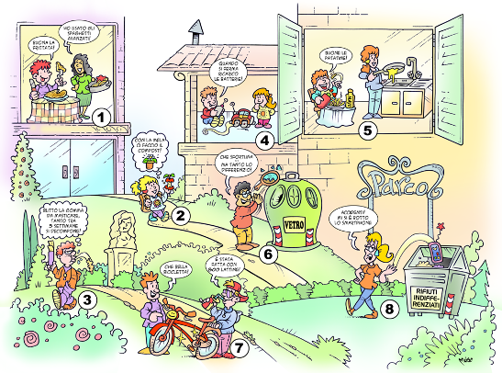

1  - BUONA LA FRITTATA!  - HO USATO GLI SPAGHETTI AVANZATI! | 1  - THIS IS YUMMY!  - I USED UP YESTERDAY’S LEFTOVERS!
2  CON LA MELA CI FACCIO IL COMPOST! | 2  I’LL THROW THIS APPLE CORE IN THE COMPOST BIN!
3  BUTTO LA GOMMA DA MASTICARE, TANTO TRA 5 SETTIMANE SI DECOMPONE! | 3  I’LL SPIT MY CHEWING GUM ON THE GROUND, IT’LL DECOMPOSE IN 5 WEEKS ANYWAY!
4  QUANDO SI FERMA RICARICO LE BATTERIE! | 4  WHEN THE BATTERIES DIE, I JUST RECHARGE THEM!
5  BUONE LE PATATINE! | 5  I LOVE FRENCH FRIES!
6  CHE SFORTUNA! MA TANTO LO DIFFERENZIO… | 6  WHAT BAD LUCK! AT LEAST I’M RECYCLING IT...
7  - CHE BELLA BICICLETTA!  - È FATTA CON 800 LATTINE! | 7  - YOUR BIKE IS AWESOME!  - IT’S MADE FROM 800 TIN CANS!
8  ACCIDENTI! MI SI È ROTTO LO SMARTPHONE | 8  UGH! MY SMARTPHONE BROKE

There are many ways to limit waste and to manage waste correctly. Find eight different situations in the picture, each marked by a number. Identify and choose the number corresponding to the four types of behaviour that you consider responsible.

Solution: 1. RIGHT (you can avoid wasting food by creating new recipes with leftovers); 2. RIGHT (with rechargeable batteries, you save energy and you protect the environment); 3. WRONG (oil used for frying is highly polluting. Do not pour it down the drain, take it to collection centres!); 4. RIGHT (you can obtain excellent organic fertiliser from organic waste); 5. WRONG (the mirror must not be thrown into the glass bin, but into the mixed rubbish bin); 6. WRONG (chewing gum takes at least five years to decompose); 7. RIGHT (cans can be recycled in many ways); 8. WRONG (a smartphone is valuable WEEE - Waste Electrical and Electronic Equipment - and must be taken to the collection centre).

n. 24 - ARE YOU ECOLOGICAL? ENERGY
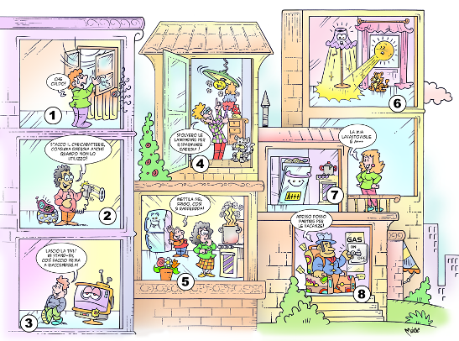

1  CHE CALDO! | 1  IT’S SO HOT IN HERE!
2  STACCO IL CARICABATTERIE, CONSUMA ENERGIA ANCHE QUANDO NON LO UTILIZZO! | 2  I UNPLUG MY CHARGER BECAUSE IT CONSUMES ENERGY EVEN WHEN I’M NOT USING IT!
3  LASCIO LA TIVU’ IN STANDBY, COSÌ FACCIO PRIMA A RIACCENDERLA! | 3  I LEAVE THE TV ON STANDBY SO IT TURNS ON QUICKER WHEN I WANT TO WATCH IT!
4  SPOLVERO LE LAMPADINE PER RISPARMIARE ENERGIA! | 4  I DUST THE LIGHT BULBS TO SAVE ENERGY!
5  METTILA NEL FRIGO, COSÌ SI RAFFREDDA! | 5  PUT IT IN THE FRIDGE, THAT’LL COOL IT DOWN!
7  LA MIA LAVASTOVIGLIE È A⁺⁺⁺ | 7  MY DISHWASHER IS A⁺⁺⁺
8  ADESSO POSSO PARTIRE PER LE VACANZE | 8  NOW I CAN GO ON HOLIDAY

To become an eco-citizen, you must try to be less “energivorous”. Find eight different situations in the picture, each marked by a number. Identify and choose the numbers corresponding to the four types of behaviour that respect the environment and allow you to live safely.

Solution: 1. WRONG (when it is too hot, do not open the windows but turn down the temperature of the radiators!); 2. RIGHT (a light bulb that is periodically dusted and cleaned gives much more light); 3. WRONG (keeping the light switched on when outside lighting is more than sufficient is useless waste); 4. RIGHT (battery chargers plugged into the electric socket continue to consume energy even when they are not connected to an electronic device); 5. RIGHT (the energy label shows the “mark” awarded to household electrical devices: those of class A, and especially those of class A+++, are more efficient and consume less); 6. WRONG (the LEDs of household electrical devices consume energy uselessly); 7. WRONG (If we put hot food in the refrigerator, the temperature rises: to restore the correct refrigeration temperature requires excess energy consumption); 8. RIGHT (if you are away from home for a few days or more, it is good practice to turn off the gas meter, to avoid potentially dangerous situations).

